**Create JSF Project**

1. Right Click on project new -> Dynamic Web Project

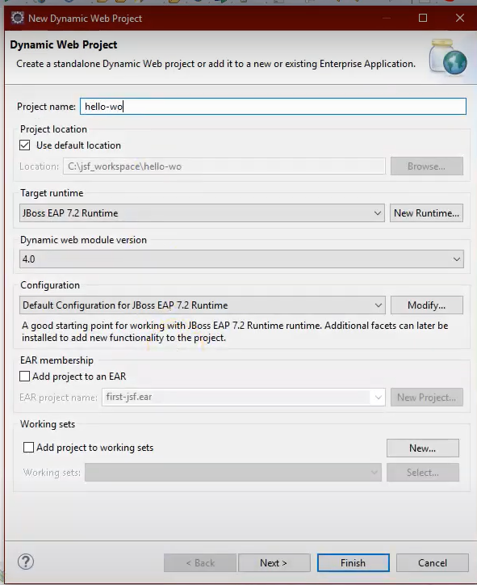

1. Click on next button.

1. Enable the check_box generate web.xml.

1. Right Click on project -> configure -> convert to maven project. Then I will generate pom.xml file.
2. Add below config in pom.xml file.

<properties>

<tomcat.version>7.0.55</tomcat.version>

<jsf.version>2.1.7</jsf.version>

</properties>

<dependency>

<groupId>javax.faces</groupId>

<artifactId>javax.faces-api</artifactId>

<version>2.0</version>

<scope>provided</scope>

</dependency>

<dependency>

<groupId>com.sun.faces</groupId>

<artifactId>jsf-api</artifactId>

<version>${jsf.version}</version>

</dependency>

<dependency>

<groupId>com.sun.faces</groupId>

<artifactId>jsf-impl</artifactId>

<version>${jsf.version}</version>

</dependency>

1. Add below config in web.xml.

<servlet>

<servlet-name>Faces Servlet</servlet-name>

<servlet-class>javax.faces.webapp.FacesServlet</servlet-class>

<load-on-startup>1</load-on-startup>

</servlet>

<servlet-mapping>

<servlet-name>Faces Servlet</servlet-name>

<url-pattern>/faces/*</url-pattern>

</servlet-mapping>

<servlet-mapping>

<servlet-name>Faces Servlet</servlet-name>

<url-pattern>*.xhtml</url-pattern>

</servlet-mapping>

//navigating page

<context-param>

<param-name>BaseUrl</param-name>

<param-value>

http://localhost:8080/jsf-project/

</param-value>

</context-param>

Create html or xhtml page under webcontent folder

We have to specify where the web.xml file is there.

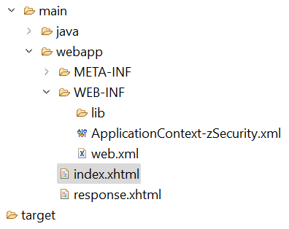

If we create an ApplicationContext-zSecurity.xml file instead of the faces-config.xml, we need to register it in the web.xml file.

**ActiveMQ:** Is a message broker. Translates messages from sender to receiver. It